Lapis: A Search Engine of the Future

Name: Le Hac Du

Id: 104841290

Lapis is the world's leading search engine, capable of rivalling cutting-edge technology companies and providing users with the best and most up-to-date information. The website consists of little but enough information for the user to understand the website purposes and where to navigate to. This report main purposes are to report on the design of the website, why is it design that way, the design functionality, and some suggestions on how the website could be better. The report will have an overview, and several paragraphs which goes through each html file individually, some insight on how the code works, whether the design is suitable, some key features and finally some drawbacks of the website and how it could be improve for better overall user experience.

The website is accessible on all devices, in my opinion the website has the best design on a computer monitor, all other devices such as the Iphone also works but the design has been twist to make it compatible to all phones.

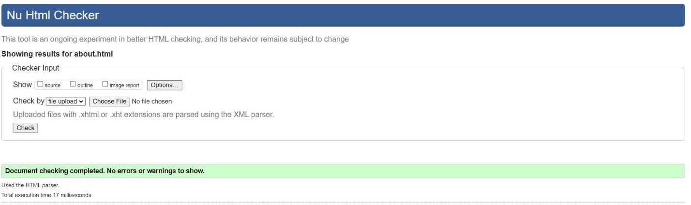

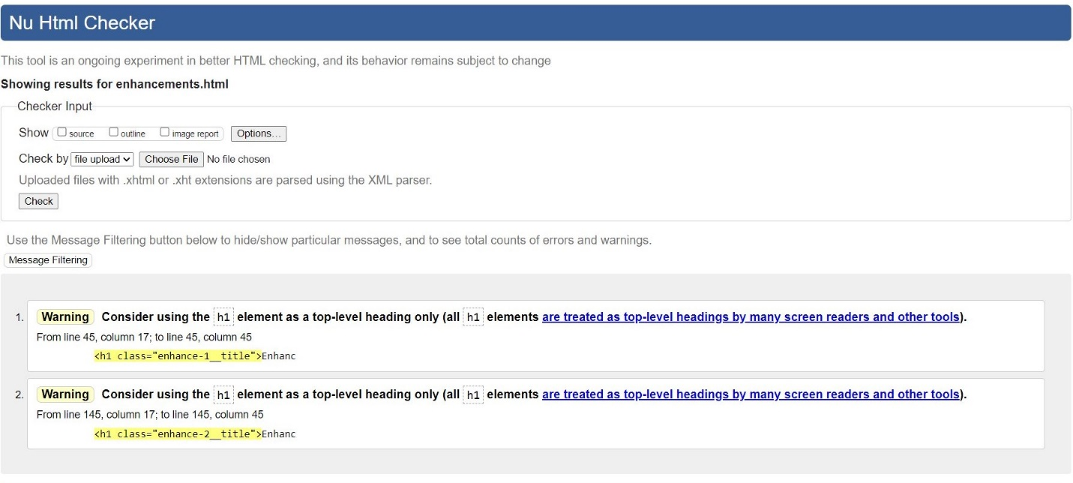

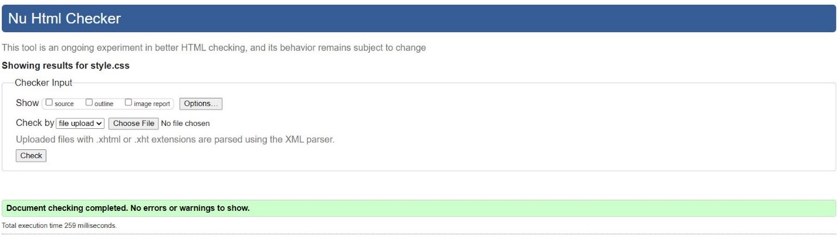

Overall, the website follow a black and blue color theme, which is usually associated to future or something from a sci-fi movie (fostergram, 2019), this theme fits perfectly with the content of the website, as the website advertise itself as an engine from the future. The website split itself into section clearly, which allow the user to navigate to their point of interests. There are different individual animations for each of the webpage to make the experience on each webpage unique to its own.

The navigation bar and footer and similar with little changes between webpages. The navigation bar give insight on what each webpage is about, and the navigation bar also changes when it is display on a phone, a design to make the website responsive on all devices. The footer is the same on all webpages giving information such as the people working on the project and contact information.

The index page is the most important page as it introduce the user to what the website is about, and the index page is going to need to be perfect as it is the first impression of the user on the website. First, the index page is created by a stunning background filled with animation with minimal words and just enough information to grab the reader attention, too many words will crowd the website and therefore makes the users lose their interests. The index page provide surface level information with dark color images and white background to create a contrast in color. There are little information about Lapis, but generally let the user know what Lapis, the search engine is about. There are uses of flex box to show what Lapis is good at, a comparison a lot of website uses to showcase their superiority. And finally, a little section showcasing the website update, it is position to look like other webpages where they would put the update section at the bottom. There is also some animation that user has to hover over the picture so they can get a glimpse on what is in the update, another way to prevent overcrowding of words.

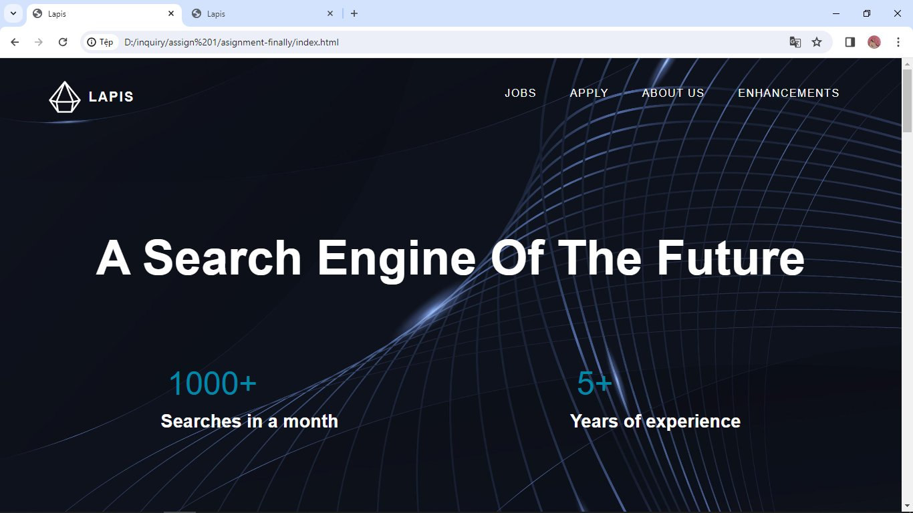

The job webpage is where applicants would first to look at when the website manages to capture their attention. A lot of websites suffer in the job webpage due to overcrowding of words, it is a difficult problem to fix as employers need to address the job information such as salary or qualifications clearly to avoid misunderstanding, Lapis job webpage has attempt to address the problem by having the largest color palate out of all webpages and bigger overall fonts to grab the user attention. There are also uses of a “read more” button to cover up the amount of words in the webpage, to make the overall experience easier to read. There is a great feature in the job webpage is that there are many hyperlinks which help the user to jump from one webpage to another easily, this help reduces the user time navigating through webpages to find their destination.

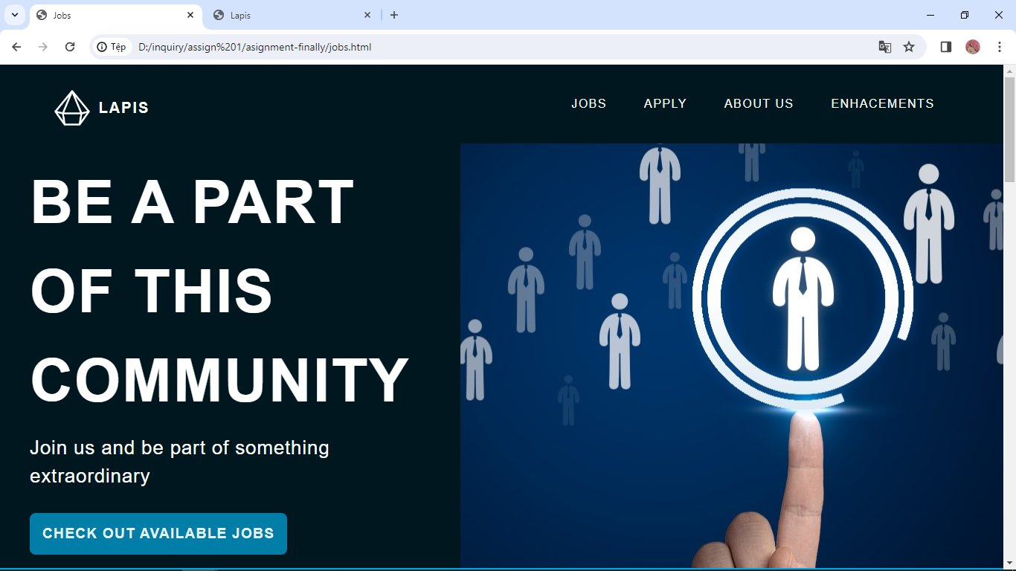

Apply webpage is one of the hardest part of the website. The apply webpage is where applicant who desire to apply for a job would go to. Therefore it is design very minimalistic, with little animation, just enough to show the applicant what they have done. The animation is mainly highlighting the box at which the applicant is clicking on to guide users. The application form are also split into small different sections for user to see all the information they need to input without sliding the mouse too much. There are a lot of struggles on this webpage due to the usage of regex, there is a lot of researches needed to make sure the user enter the correct information to prevent an error application or bots trying to overload the website.

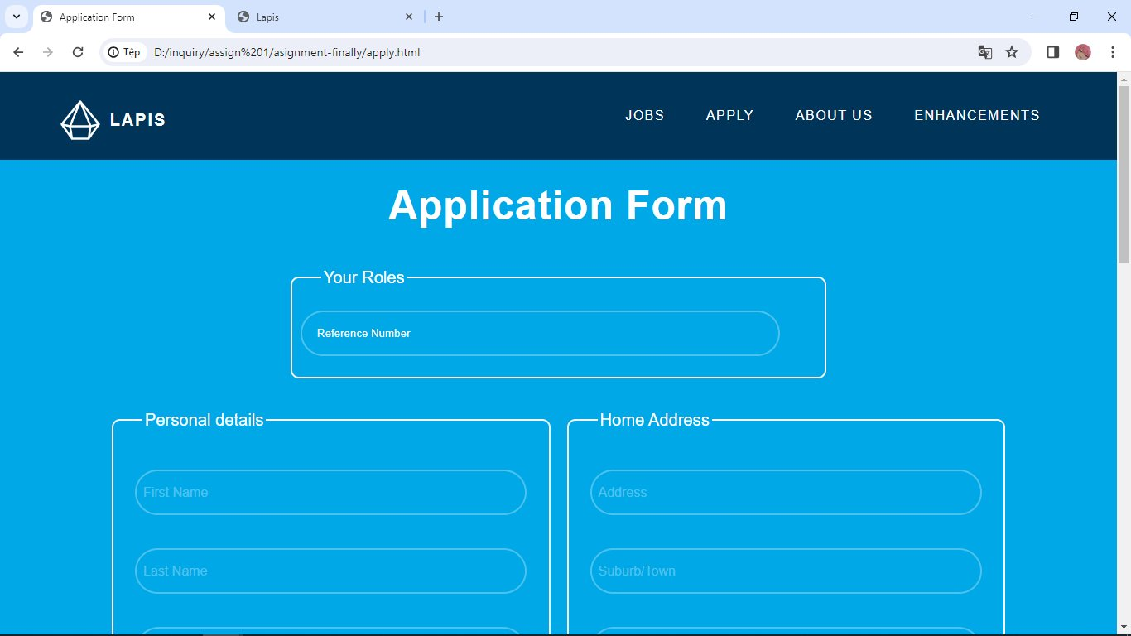

All website has an about us webpage to clarify to the user who are the people that work on the project. The about us webpage is relatively simple, just enough informations for the user to know about the website and the people working on it. The webpage has one big headline to let the users know what this webpage is going to mainly discuss about. The headline is also put in a picture background which none of the other section of the about us page has. The about us webpage is heavily reliant on animation which is why this page tend to run slower than other pages. There are group photo with a zoom animation when user hover their mouse over it. The picture is also medium size to prevent the picture from looking too small for the user to see or too big that crowded the page. Then there is a mission, values, and goals section which many websites has to showcase the user what was the ultimate purpose of the websites are. This section has many animation which reshapes the box, the images on it, and also uncover content of the card inside it. Each box has its own distinct color to separate itself from another. The next section is going to be individual introduction, the user get to see who was inside this project, with their picture position on one side which the other side has their information such as their name or position. The terms such as their position are highlight into different lines so the user can read easier. Beneath the information there are also contact information which when hover changes their effect. Each individual are position zigzag with different color so it create a dynamic in the webpage. Last but not least a simple timetable at the bottom of the page, a simple timetable with different color to show the user which information is which. Overall, this webpage has the most animation out of all and the picture are also heavy on storage which make this page slower than other pages.

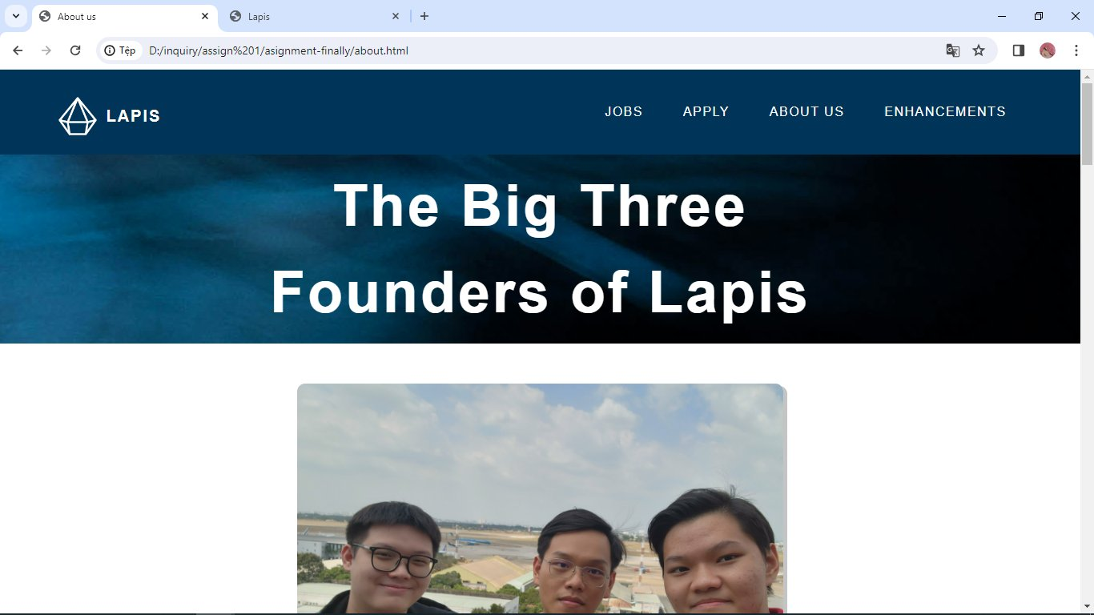

The final page on the website is the enhancement page. There are nothing much special on this page except showcasing what was the highlight on the website. This page give a brief explanation on the animation and why it is included in the website. There is a link which would hyperlink the user to where the animation is used, follow by a short explanation on how the animation work in details. The most impressive part on this webpage is that there is a code left for user to see and understand how the code work in detail, with a small overall explanation on the code.

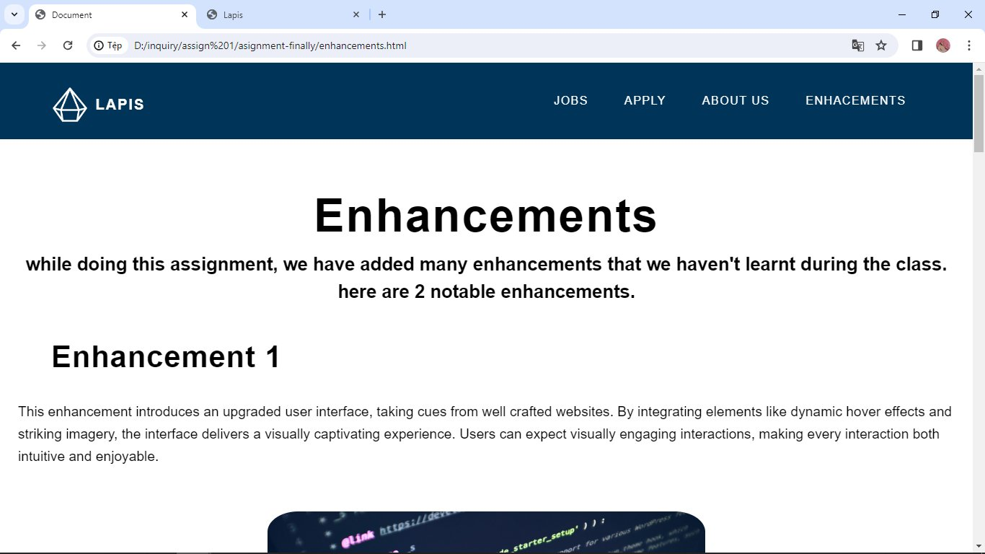

Our website has a lot of animation and the animation are place appropriately mainly to prevent the user from getting bored. Both enhancements has a lot in similarity but used in different way, the first enhancement works by hiding all words from the user, which let the user curiosity to hover over the image to know what the content is about, this is appropriate here on the update section, because the update are not always the same, it could be update on the system or a market update, this enhancement provide users a little game-like experience for them to guess which update is this picture related to. The second enhancement showcase the user what the card is going to be about but hide the content away, this second enhancement not only move the image away, it also reshape the images to show a full image. This enhancement is appropriate because the content is already made known to the user in the section headline, which make the user spend less time and hover straight to the content they are interested to know about.

I am responsible for making the about us webpage, and the tester of the group, many bugs and responsive problems I had to help fixing during the process of making of the website. The challenges I mainly faced is the lack of idea, at first it was not the lack of idea, but rather would the idea work on this section or not, we had to create our own webpage and each of them had to link one way or another but also with their uniqueness, I had try other options but they failed due to unable to be responsive on other devices, there are also many problems such as images moving around when adjusted to certain width, which took us a lot of time to fix.

In conclusion, the website is done well overall, I am proud of the website and what it has become. The website showcase clear and distinct section, make the user experience interactive and most important of all, all webpages are responsive on all devices. Some suggestions that I believe would increase the website overall is adding more color, although the color itself clearly set the expectation for what the website is about, but there are still a lot of white background which could cause discomfort for people sitting in a dark room, second is that we should focuses more on animation, I did say animation was slowing the webpage down, but if we compress the images to smaller sizes, it would create more data spaces for animation without slowing the website down.

Reference:

The Future is Blue (2019), *fostergram*,

<https://fostergram.wordpress.com/2019/11/03/the-future-is-blue/>